Normalization / Scaling

Definition
# Source: AI Source: Provided by: [Data Path: Persons Table -> ID Column: 1, Name_En Column: Motasem Essam] -> From: [Chatgpt (GPT‑5 Mini)] on [12/10/2025]
Normalization (or Scaling) is a data transformation technique used to adjust numerical feature values to a common scale without distorting differences in the ranges of values. It is commonly used in data preprocessing for machine learning and statistical analysis.
Many machine learning algorithms perform better when numerical features are on similar scales, because large-value variables can dominate smaller-value variables.

Key Idea
# Source: AI Source: Provided by: [Data Path: Persons Table -> ID Column: 1, Name_En Column: Motasem Essam] -> From: [Chatgpt (GPT‑5 Mini)] on [12/10/2025]
Normalization transforms values from their original range into a standardized range, usually between 0 and 1.
Example:
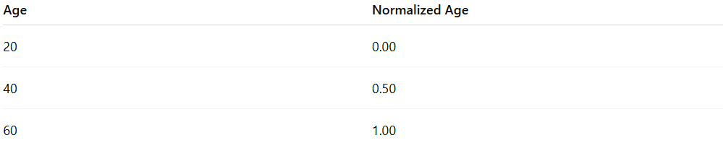
Age | Normalized Age
20 | 0.00
40 | 0.50
60 | 1.00

Characteristics
# Source: AI Source: Provided by: [Data Path: Persons Table -> ID Column: 1, Name_En Column: Motasem Essam] -> From: [Chatgpt (GPT‑5 Mini)] on [12/10/2025]
- Converts features to a comparable numeric scale
- Helps improve model convergence and stability
- Prevents features with large values from dominating the model
- Frequently used in machine learning preprocessing
- Applied mainly to numerical variables

Common Methods of Normalization

1. Min-Max Normalization
# Source: AI Source: Provided by: [Data Path: Persons Table -> ID Column: 1, Name_En Column: Motasem Essam] -> From: [Chatgpt (GPT‑5 Mini)] on [12/10/2025]
Transforms data to a fixed range, typically 0 to 1.
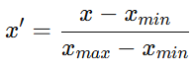
x' = \frac{x - x_{min}}{x_{max} - x_{min}}
Example:
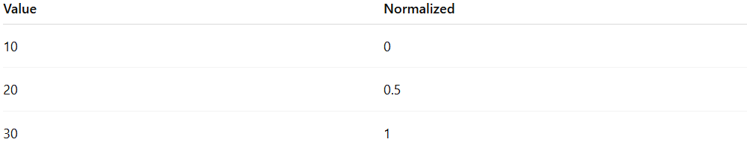
Value | Normalized
10 | 0
20 | 0.5
30 | 1

2. Z-Score Standardization
# Source: AI Source: Provided by: [Data Path: Persons Table -> ID Column: 1, Name_En Column: Motasem Essam] -> From: [Chatgpt (GPT‑5 Mini)] on [12/10/2025]
Rescales data based on mean and standard deviation, producing values centered around 0.
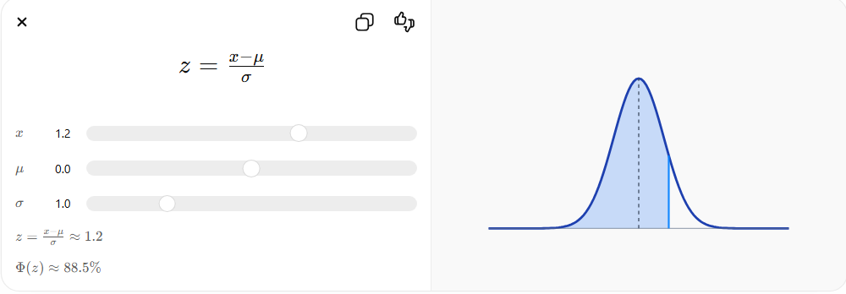
Where:
- $μ$= mean
- $σ$= standard deviation
Example:
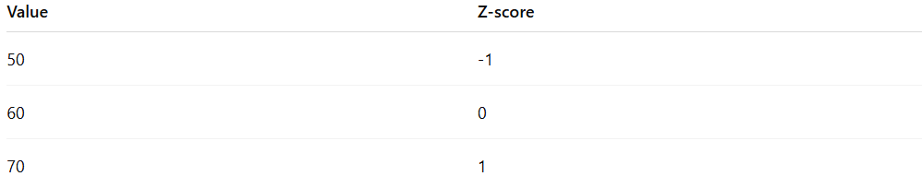
Value | Z-score
50 | -1
60 | 0
70 | 1

3. Decimal Scaling
# Source: AI Source: Provided by: [Data Path: Persons Table -> ID Column: 1, Name_En Column: Motasem Essam] -> From: [Chatgpt (GPT‑5 Mini)] on [12/10/2025]
Moves the decimal point of values based on the maximum absolute value in the dataset.
Example:
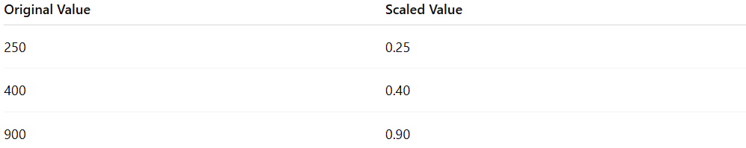
Original Value | Scaled Value
250 | 0.25
400 | 0.40
900 | 0.90

Example
# Source: AI Source: Provided by: [Data Path: Persons Table -> ID Column: 1, Name_En Column: Motasem Essam] -> From: [Chatgpt (GPT‑5 Mini)] on [12/10/2025]
Original dataset:
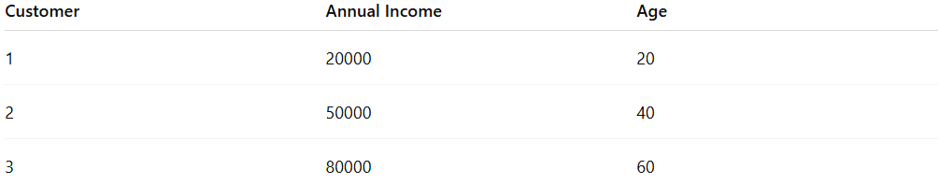
Customer | Annual Income | Age
1 | 20000 | 20
2 | 50000 | 40
3 | 80000 | 60
After Min-Max Normalization:
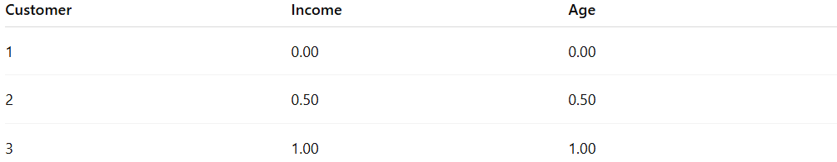
Customer | Income | Age
1 | 0.00 | 0.00
2 | 0.50 | 0.50
3 | 1.00 | 1.00

Advantages
# Source: AI Source: Provided by: [Data Path: Persons Table -> ID Column: 1, Name_En Column: Motasem Essam] -> From: [Chatgpt (GPT‑5 Mini)] on [12/10/2025]
- Improves model training efficiency
- Ensures features contribute equally to the analysis
- Helps algorithms such as KNN, SVM, and Neural Networks
- Reduces numerical instability

Disadvantages
# Source: AI Source: Provided by: [Data Path: Persons Table -> ID Column: 1, Name_En Column: Motasem Essam] -> From: [Chatgpt (GPT‑5 Mini)] on [12/10/2025]
- Sensitive to outliers (especially Min-Max normalization)
- May reduce interpretability of original values
- Requires consistent scaling for training and test datasets

